MINI PROJECT REPORT

ON

“Automatic Device Controller Using Motion Sensors”

Submitted in Partial Fulfilment of the Requirements for the

Degree of Bachelor of Engineering

In

Electronics and Telecommunication

By

Kadam Gauri Anil (PRN No.-71819624E)

Kaushiki K.B (PRN No.-71819546K)

Vaishnavi Ukarande (PRN No.-72002503G)

Under the Guidance

Of

Prof.AP.Yadav

Department of Electronics and Telecommunication Engineering, BHARATI VIDHAPEETH’S COLLEGE OF ENGINEERING FOR WOMEN, PUNE-43

2019-20

Affiliated

to



Savitribai Phule Pune University

Department of Electronics and Telecommunication Engineering,

BHARATI VIDYAPEETH’S COLLEGE OF ENGINEERING FOR WOMEN, PUNE-43

CERTIFICATE

This is to Certify that the Mini Project Report Entitled

”Automatic Device Controller Using Motion Sensors”

Submitted

By

Kadam Gauri Anil (PRN No.-71819624E)

Kaushiki K.B (PRN No.-71819546K)

Vaishnavi Ukarande (PRN No.-72002503G)

It is a bonafied work carried out satisfactorily by them under supervision and guidance and it is submitted towards the partial fulfilment of the requirements of Savitribai Phule Pune University, Pune for the award of degree, Bachelor of Engineering (Electronics and Telecommunication) during the academic year 2019-20.

Place: Pune

Date:

Prof.AP.Yadav

(Guide) (Head of the Department)

(Principal)

BVCOEW Baramati

Contents

Acknowledgement

List of Figures

List of Abbreviation

1 INTRODUCTION

1 1.1 Motivation . . . . . . . . . . . . . . . . . . . . . . . . . . . . . . . . . . .

1 1.2 Objective . . . . . . . . . . . . . . . . . . . . . . . . . . . . . . . . . . .

2 1.3 Block Schematic . . . . . . . . . . . . . . . . . . .

3 3 Hardware Specification

5 3.1 Hardware Design . . . . . . . . . . . . . . . . . . . . . . . . . . . . . . .

5 3.1.1 ESP-8266(NODE MCU). . . . . . . . . . . . . . . . . . . . . . . . . . . . .

5 3.1.2 Motion Sensor. . . . . . . . . . . . . . . . . . . . . . . . . 6 3.1.3 Light Emitting Diode . . . . . . . . . . . . . . . . . . . . . . . . .

7 3.1.4 Relay . . . . . . . . . . . . . . . . . . . . . . . . . . . . . . . . .

8 3.2 Circuit Diagram . . . . . . . . . . . . . . . . . . . . . . . . . . . . . . . .

9 3.3 Software Design . . . . . . . . . . . . . . . . . . . . . . . . . . . . . . . .

10 3.3.1 Blynk Application . . . . . . . . . . . . . . . . . . . . . . . . . .

11 4 Hardware Setup 12 4.1 Hardware Implementation . . . . . . . . . . . . . . . . . . . . . . . . . . . 12 5 RESULTS AND CONCLUSION

13 5.1 Implementation Results . . . . . . . . . . . . . . . . . . . . . . . . . . . .

13 5.2 Conclusion . . . . . . . . . . . . . . . . . . . . . . . . . . . . . . . . . .

13 References

ACKNOWLEDGEMENT

We express our gratitude to all those without whose undying support and cooperation this project could not have been completed. we would like to thank our guide Prof.AP.Yadav. For the valuable guidance and advise. His contribution towards our project is tremendous. We wish to express our heartfelt gratitude to the Electronics and Telecommunication Department staff for there suggestions that indebted help to complete this work successfully. We thank our project coordinator HOD and our Honourable Principal for providing us with well- equipped facilities and good environment. Warm thanks to family and friends for constant support.

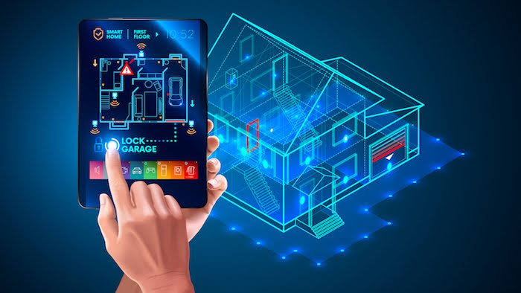

List of Figures

● NODEMCU esp8266

● PIR Motion Sensor

● LED

● Relay

* List of Abbreviations
* ESP-8266 Espressif Systems
* IC Integrated Circuit
* LED Light Emitting Diode
* PIR Passive Infrared Sensors

INTRODUCTION

* It is a concept which helps to build a wireless network among the different devices accessed through internet and various IP protocols.
* It creates an ecosystem among devices which makes it accessible remotely and things which represents the devices like sensors, microcontrollers, and mobile phones that’s connected to a wireless network.
* The resulting network is usually referred to Internet of thing of real time problems and have improved the flexibility of various existing systems.
* Evolution of technology have always encouraged the use of Wi-Fi which eradicates the need of wired connection and thus reducing the cost and complexity of the system.
* In this case the Wi-Fi module, Node MCU (esp8266), act as a gateway to connect the home appliances to the Blynk server and those appliances can be triggered remotely through the Blynk mobile app.
* Additionally, this Internet based home automation system has been integrated with passive infrared sensor (PIR sensor) which makes the system work when there is any physical movement.

METHODOLOGY

* Mainly the project is a concept to bring automation in the home. All the home appliances will be controlled via Blynk mobile app and also by detecting any physical movements across the room.
* The appliances in the home will be interfaced with centralized micro controller Node MCU for the organized working.
* The controller also interfaced with WIFI to receive the control commands from Wi-Fi shield (Wi-Fi hotspot) and through Blynk servers those appliances can be triggered.
* The operator will be provided with the Blynk app on a Wi-Fi enabled smart phone. If an operator wants to switch the appliances to on or off, he needs to switch the button provided in Blynk app.
* Once he’s done, the Blynk app will send the data to the Blynk servers and receives the response back to the microcontroller accordingly and when the request is received by the microcontroller it activates the specific appliance.
* In the same way all other appliances can be controlled. In addition to that a PIR motion sensor has been added to the Node MCU which detects the motion within a defined range and controls the appliances based on the detected inputs.

Motivation

It can be used to turn ON and OFF the appliances of the home automatically by detecting the presence of humans. This system can be used to remote in garages, fan, household appliances classrooms, staircases, bathrooms, etc. where there is no need for continuous light but only when there is a human. Also, there is no need to worry about electricity bills as the lights get OFF when there is no human and hence one needs to pay the bills as peruse. The main components used in this system areESP-8266, PIR, and Relay Module. Out of these components, the operation of the system mainly depends on the PIR sensor which helps in detecting human presence. From all these problems we realized that there is a need of automatic monitoring system for agriculture in remote areas, urban areas. The advantages of this project is automatically control conditions within field allowing all the system to work properly

Objective

• Automatic switch device,

• Remote monitoring of parameters.

• Improves Home Security

• Minimize cost of production.

* Minimize the consumption of electrical power.
* It is a low-cost device
* Security systems
* For minimizing the load shedding in the cities and villages.
* HARDWARE SPECIFICATION

The components used are,

● NODEMCU esp8266

● PIR Motion Sensor

● LED

● Relay

* Hardware Setup
* Hardware Implementation

1. ESP-8266

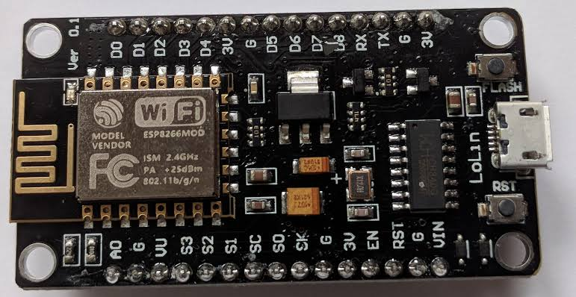

*ESP-8266 Chip Board*

The ESP8266 is a low-cost Wi-Fi microchip, with a full TCP/IP stack and microcontroller capability. The ESP8285 is an ESP8266 with 1 MiB of built-in flash, allowing the building of single-chip devices capable of connecting to Wi-Fi. Processor: L106 32-bit RISC microprocessor core based. It 106Micro running at 80 MHz Memory: 32 KiB instruction RAM 32 KiB instruction cache RAM 80 KiB user-data RAM 16 KiB ETS system-data RAM External QSPI flash: up to 16 MiB is supported (512 KiB to 4 MiB typically included)

* SPECIFICATIONS

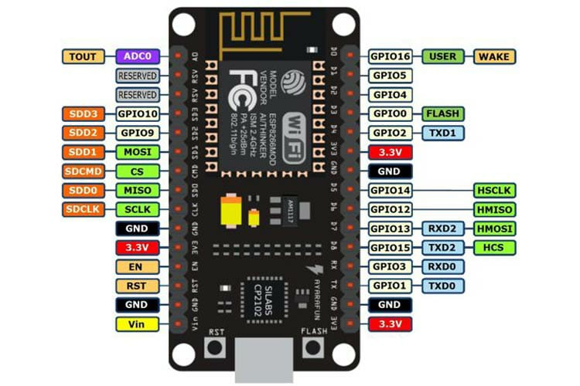

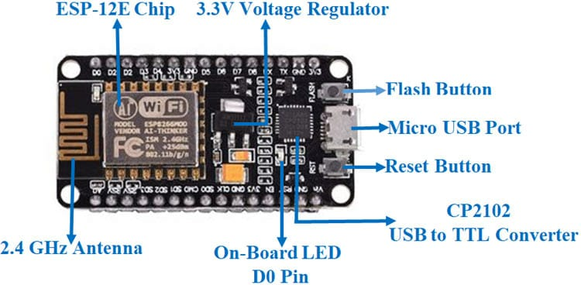

1. zPassive Infrared Sensor (PIR Sensor)

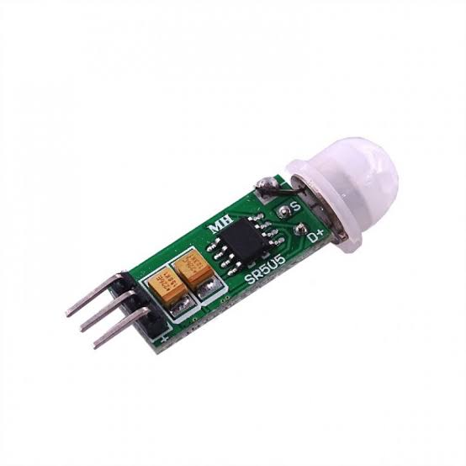

*(PIR sensor)*

It is an electronic sensor which measures infrared (IR) radiation in its field of view from objects. They are most widely used in motion-detectors based on PIR. These sensors are widely used in safety alarms and automatic lighting. PIR sensors sense general movement, but don't have information on who moved or what. An active IR sensor is necessary for this purpose. PIR sensors are generally referred as "PIR" or sometimes as "PID" for "passive infrared detectors." The term passive refers to the fact that PIR devices for detection purposes don't radiate energy, instead they work entirely by detecting infrared radiation (radiant heat) emitted by objects or reflected from them

1. Light Emitting Diode

LED is a semiconductor light source that emits light when current flows through Light Emitting Diode. LED have High luminous power. LED is Bulk, available taped on reel.

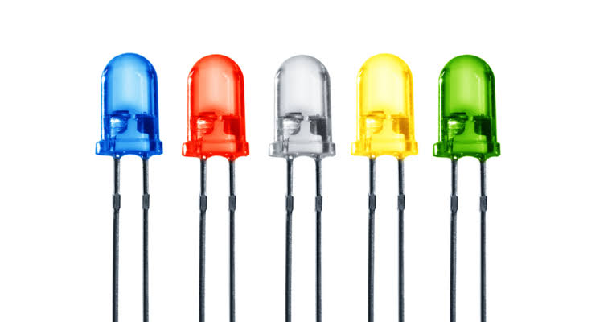

1. Relay

A relay operates as an electromagnetic switch. It can control a high voltage circuit by using only a low voltage control signal. The building components of an electro chemical relay are basically a fixed coil, a movable armature, a spring and contacts. Electro mechanical relays are categorized into two types, Normally Open NO and Normally Closed NC.

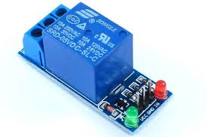

*Relay*

* Circuit Diagram
* CONNECTING NODEMCU TO SENSOR AND RELAY

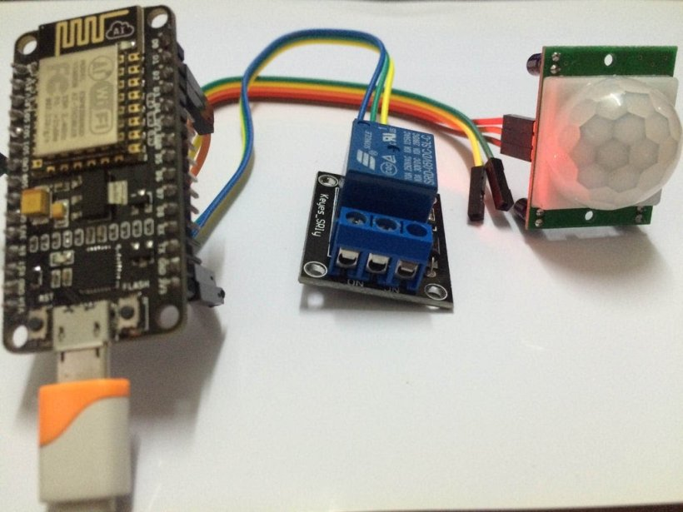

* NodeMCU _______Sensor ________Relay
* VIN______ Not Connected ________VCC(+)
* 3.3V_______+________Not Connected
* GND________-________GND
* D2_________OUT__________Not Connected
* D1_________Not Connected _________Signal
* Software Design
* Flowchart

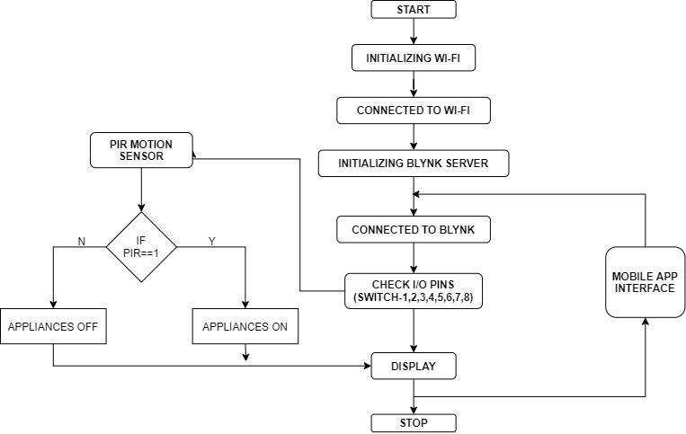

* Blynk Application
* Blynk

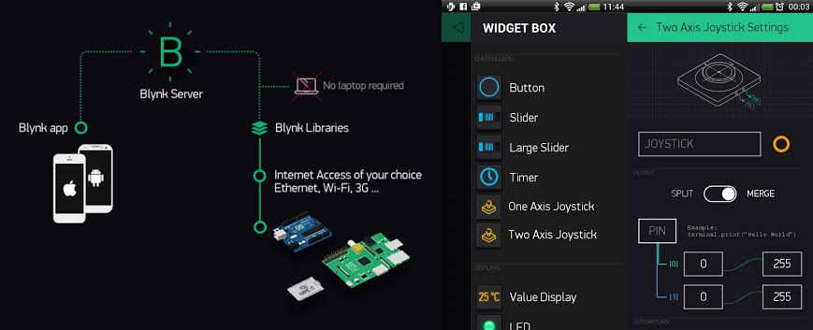

Blynk was designed for the Internet of Things. It can control hardware remotely, it can display sensor data, it can store data, visualize it and do many other cool things. There are three major components in the platform: Blynk App - allows to you create amazing interfaces for your projects using various widgets we provide. Blynk Server - responsible for all the communications between the smartphone and hardware. You can use our Blynk Cloud or run your private Blynk server locally. It’s opensource, could easily handle thousands of devices and can even be launched on a Raspberry Pi. Blynk Libraries - for all the popular hardware platforms - enable communication with the server and process all the incoming and out coming commands. Here, we are using interface to continuously monitor and control the environmental parameters.

RESULTS AND CONCLUSION

However, the working prototype of our home automation system has been tested and implemented. Since it comprises of PIR sensor, the appliances work only if there is any physical motion with the defined range. All the appliances connected to the board can be monitored remotely with the Blynk mobile application which works flawlessly on both the android and iOS devices as well. This prototype can be used to solve real world problems, automating many devices The instance and substantial amount of electricity can be saved by switching off the appliances/devices when there is no any physical motion. As a future enhancement, with this prototype which would allow us to elicit data such as distance to and from an object/human and with those data the precision of human motion detection can be improved. To sum it up all, perhaps this prototype might sound simple yet the concept behind this will bring a drastic change in day -day life, and for the betterment of the society.

REFERENCE

[11:42 PM, 6/14/2021] Gauri: [1] https://www.iea.org/countries/algeria

[2] https://www.iea.org/policies/6103-renewable-energy-and-energy-

efficiency-development-plan-2015-2030

[3] Bouznit, M.; Pablo-Romero, M.P.; Sánchez-Braza, A. Residential

Electricity Consumption and Economic Growth in Algeria. Energies

2018, 11, 1656.

[4] M. Missoum, A. Hamidat, L. Loukarfi, Energy Performance

Simulations of a Grid-connected PV System Supplying a Residential

House in the North-western of Algeria, Energy Procedia, Volume 50,

Pages 202-213, 2014,

[5] Fathia Chekired, Achour Mahrane, Zoubeyr Samara, Madjid Chikh,

Abderrazak Guenounou, Aissa Meflah, Fuzzy logic energy

management for a photovoltaic solar home, Elsevier, Energy Procedia

134 (2017) 723-730.

[6] Tascikaraoglu A, Boynuegri A.R, Uzunoglu M. A demand side

management strategy based on forecasting of residential renewable

sources: A smart home system in Turkey. Energ Buildings 2014;

80:309–320.

[7] L.T. Doulos, A. Kontadakis, E.N. Madias, M. Sinou, A.

Tsangrassoulis, Minimizing energy consumption for artificial lighting

in a typical classroom of a Hellenic public school aiming for near

Zero Energy Building using LED DC luminaires and daylight

harvesting systems, Energy and Buildings, Volume 194, 2019, Pages

201-217, ISSN 0378-7788,

https://doi.org/10.1016/j.enbuild.2019.04.033.

[8] Dubois, M. C., & Blomsterberg, Å. (2011). Energy saving potential

and strategies for electric lighting in future North European, low

energy office buildings: A literature review. Energy and Buildings,

43(10), 2572-2582.

[9] L.T. Doulos, A. Tsangrassoulis, P.A. Kontaxis, A. Kontadakis, F.V.

Topalis, Harvesting daylight with LED or T5 fluorescent lamps? The

role of dimming, Energy and Buildings, Volume 140, 2017, Pages

336-347, ISSN 0378-7788,

https://doi.org/10.1016/j.enbuild.2017.02.013.

[10] L. Doulos, A. Tsangrassoulis, F.V. Topalis, Multi-criteria decision

analysis to select the optimum position and proper field of view of a

photosensor, Energy Conversion and Management, Vol. 86, 2014,

pp1069-1077, DOI : 10.1016/j.enconman.2014.06.032.

[11] Akanmu, A., Anumba, C., & Messner, J. (2013). Active Monitoring

and Control of Light Fixtures during Building Construction and

Operation: Cyber-Physical Systems Approach. Journal of

Architectural Engineering, 20(2), 04013008.

[12] Tan, Y. K., Huynh, T. P., & Wang, Z. (2013). Smart personal sensor

network control for energy saving in DC grid powered LED lighting

system. Smart Grid, IEEE Transactions on, 4(2), 669-676.

[13] B. Mizon, (2012). Light pollution: responses and remedies. Springer

Science & Business

THANK YOU